UPI FRAUD DETECTION USING RANDON FOREST ALGORITHM
Project Report
Submitted to the Faculty of Engineering of
JAWAHARLAL NEHRU TECHNOLOGICAL UNIVERSITY KAKINADA, KAKINADA
In partial fulfillment of the requirements for the award of the Degree of

BACHELOR OF TECHNOLOGY

In

CSE (ARTIFICIAL INTELLIGENCE & MACHINE LEARNING)
By
VANKAYALAPATI NIKHITA (22481A42B8)
TUNUGUNTLA GOURI NITEESHA (22481A42B4)
PERAVALI VEDA SAI (23485A4214)
PITTA VYSHNAVI (22481A4287)

Under the Enviable and Esteemed Guidance of

Dr. Y. ADILAKSHMI, M. Tech, Ph.D
Professor & Head of the Department,
CSE (ARTIFICIAL INTELLIGENCE & MACHINE LEARNING)


DEPARTMENT OF CSE (ARTIFICIAL INTELLIGENCE & MACHINE LEARNING)

SESHADRI RAO GUDLAVALLERU ENGINEERING COLLEGE
(An Autonomous Institute with Permanent Affiliation to JNTUK, Kakinada) SESHADRIRAO KNOWLEDGE VILLAGE GUDLAVALLERU – 521356
ANDHRA PRADESH
2024-25

SESHADRI RAO GUDLAVALLERU ENGINEERING COLLEGE
(An Autonomous Institute with Permanent Affiliation to JNTUK, Kakinada)
SESHADRI RAO KNOWLEDGE VILLAGE, GUDLAVALLERU
DEPARTMENT OF CSE (ARTIFICIAL INTELLIGENCE & MACHINE LEARNING)



CERTIFICATE

This is to certify that the project report entitled “UPI FRAUD DETECTION USING RANDON FOREST ALGORITHM ” is a Bonafide record of work carried out by VANKAYALAPATI NIKHITA (22481A42B8) ,TUNUGUNTLA GOURI NITEESHA (22481A42B4),PERAVALI VEDA SAI (23485A4214),PITTA VYSHNAVI (22481A4287), under the guidance and supervision of Dr. Y. ADILAKSHMI, Professor and Head of the Department, CSE (Artificial Intelligence & Machine Learning), in the partial fulfillment of the requirements for the award of the degree of Bachelor of Technology in Computer Science and Engineering of Jawaharlal Nehru Technological University Kakinada, Kakinada during the academic year 2024-25.

Project Guide Head of the Department
(Dr. Y. ADILAKSHMI) (Dr. Y. ADILAKSHMI)

ACKNOWLEDGEMENT

The satisfaction that accompanies the successful completion of any task would be incomplete without the mention of people who made it possible and whose constant guidance and encouragements crown all the efforts with success.

We would like to express our deep sense of gratitude and sincere thanks to Dr. Y. ADILAKSHMI, Professor & Head of the Department, CSE (Artificial Intelligence & Machine Learning) for her constant guidance, supervision and motivation in completing the project work.

We feel elated to express our floral gratitude and sincere thanks to Dr. Y. ADILAKSHMI, Head of the Department, CSE (Artificial Intelligence & Machine Learning) for her encouragements all the way during analysis of the project. Her annotations, insinuations and criticisms are the key behind the successful completion of the project work.

We would like to take this opportunity to thank our beloved principal Dr. B. KARUNA KUMAR for providing a great support for us in completing our project and giving us the opportunity for doing project.

Our Special thanks to the faculty of our department and programmers of our computer lab. Finally, we thank our family members, non-teaching staff and our friends, who had directly or indirectly helped and supported us in completing our project in time.

Team Members
VANKAYALAPATI NIKHITA (22481A42B8)
TUNUGUNTLA GOURI NITEESHA (22481A42B4)
PERAVALI VEDA SAI (23485A4214)
PITTA VYSHNAVI (22481A4287)

INDEX

TITLE PAGENO

LIST OF TABLES i
LIST OF FIGURES ii
ABSTRACT iii

CHAPTER 1: INTRODUCTION 1
  - Introduction
  - Problem definition 3
CHAPTER 2: PROPOSED METHOD 4
  - Methodology
    - Flow Chart
    - Algorithm and Explanation
  - Data Preparation 7
    - Data Description
    - Data Pre-processing
CHAPTER 3: RESULTS 11
CHAPTER 4: CONCLUSION AND FUTURE SCOPE 14

References
List of Program Outcomes and Program Specific Outcomes Mapping of Program Outcomes with graduated POs and PSOs

ABSTRACT

Unified Payments Interface (UPI) has transformed digital finance in India, enabling seamless and instant money transfers. However, its rapid growth has been accompanied by an increase in fraudulent transactions. This project focuses on detecting UPI fraud using machine learning techniques. The dataset underwent extensive preprocessing, including the removal of redundant ID-based columns and the extraction of date-based features such as year and month. Exploratory data analysis (EDA) was conducted to understand patterns and trends in both normal and fraudulent transactions. Various classification models were evaluated to distinguish between legitimate and fraudulent activities, with performance measured through metrics such as accuracy, precision, and recall. The results indicate that machine learning models can effectively identify fraudulent behavior, providing a valuable tool for enhancing transaction security and reducing financial risk in UPI-based systems.
Keywords:Time,Customer_Age,Year,Month,Merchant_Category,Location,Amount, Is_Fraud,Label_encoding,Data preprocessing,Decision tree,Random Forest ,Testing ,
Training ,Model Accuracy

CHAPTER 1

INTRODUCTION

1.1 Introduction

Over the last few years, the Unified Payments Interface (UPI) has transformed the Indian payment system by allowing instant, secure, and real-time digital transactions. With the ease of usage, 24x7 service, and interoperability across banks, UPI has emerged as the go-to payment mode for crores of people in the country.

But the sudden surge in UPI growth has also invited a rise in fraudulent activities such as phishing attacks, imitation UPI apps, QR code scams, and account hijacking. These spurious transactions cause huge financial losses to users as well as financial institutions, creating a critical threat to the trust and reliability of the UPI system.

Rule-based traditional fraud detection systems are no longer adequate, as they fail to keep pace with the sophisticated and changing patterns of contemporary fraud schemes. Thus, intelligent data-driven solutions are increasingly needed that can actively detect fraudulent activity in real-time.

This project meets this challenge by using machine learning algorithms to identify fake UPI transactions. The system learns the patterns of valid and fake transactions from historical transaction data. Preprocessing raw transaction data, feature engineering, and model training using models like Decision Tree Classifier and Random Forest Classifier are part of the project.

1.2 Problem Statement

Unified Payments Interface (UPI) has become a widely adopted digital payment platform in India due to its simplicity, speed, and convenience. However, the exponential growth of UPI transactions has led to an increase in fraudulent activities, including phishing, fake apps, and transaction manipulation.

Traditional fraud detection systems are largely rule-based and struggle to detect evolving and complex fraud patterns in real-time. These systems often generate high false positives or miss fraudulent cases altogether, leading to financial losses and reduced user trust.

To address this challenge, this project proposes the development of a machine learning-based fraud detection system. By analyzing historical transaction data and training classification models such as Decision Tree and Random Forest, the goal is to accurately distinguish between legitimate and fraudulent UPI transactions, thereby enhancing security, reducing risks, and supporting the scalability of digital payments.

CHAPTER 2
PROPOSED METHOD

2.1 METHODOLOGY
The system under consideration proposes to identify fraudulent UPI transactions with the help of machine learning models. The process is to gather transaction data, preprocess it, choose features, train machine learning models, and test them for accuracy.
The most important steps undertaken in the process are:
- Data Collection from UPI transaction datasets
- Preprocessing and cleaning of data
- Label encoding and feature selection
- Splitting data into training and testing sets
- Applying classification algorithms (Decision Tree and Random Forest)
- Assessing model performance based on metrics such as accuracy, precision, recall, and confusion matrix

2.1.1 Flow Chart

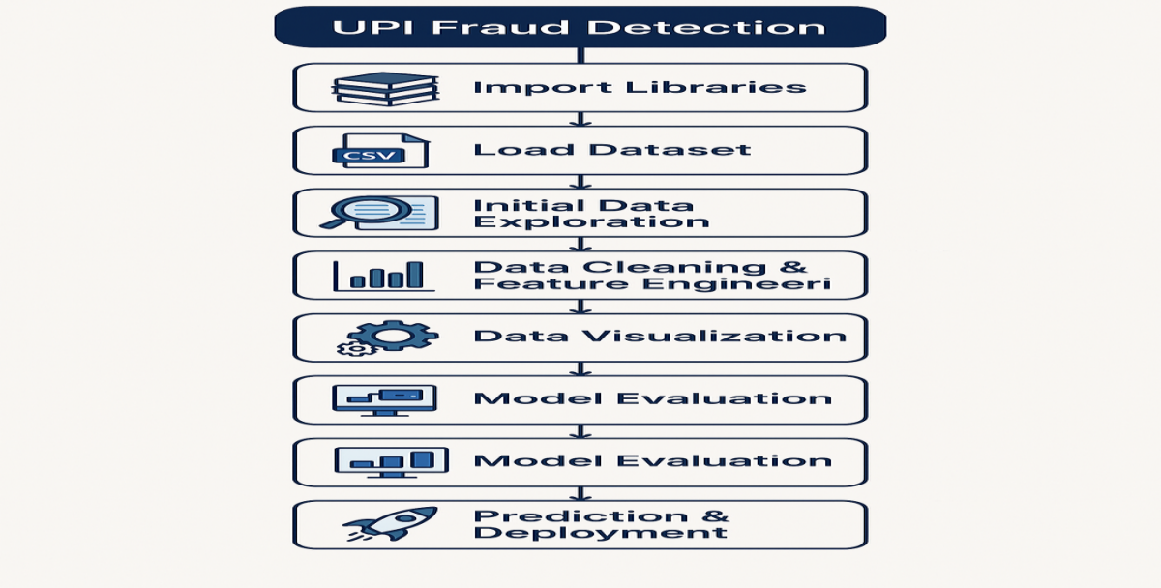
Fig 2.1.1 Flow chart

- It describes how the flow of this project.
2.1.2 Algorithm and Explanation
The objective of this project is to accurately detect fraudulent transactions within a large dataset of UPI transactions. To achieve this, we have utilized supervised machine learning algorithms, which are trained on labeled data (i.e., transactions labeled as “fraud” or “not fraud”).
Two classification algorithms were selected based on their effectiveness in fraud detection problems:
- Decision Tree Classifier
- Random Forest Classifier
Both models were implemented using the Scikit-learn machine learning library in Python. The following sections explain the internal workings, advantages, drawbacks, and implementation strategies for each algorithm in detail.

1. Decision Tree Classifier
Overview:
A Decision Tree is a non-parametric supervised learning algorithm used for both classification and regression. It works by learning simple decision rules inferred from data features to predict the target variable.
Each internal node of the tree represents a decision based on a feature, each branch represents an outcome of that decision, and each leaf node represents a class label (in our case: fraud or not fraud).
Working Mechanism:
- The tree starts from the root node, where the algorithm finds the best feature to split the data.
- It chooses the feature and split value that leads to the highest information gain (using criteria like Gini Impurity or Entropy).
- The dataset is divided into subsets based on the selected feature.
- This process is repeated recursively, building branches until a stopping condition is met (e.g., maximum depth, minimum number of samples).
Mathematical Concepts:
- Gini Impurity: Measures how often a randomly chosen element would be incorrectly labeled. Lower values are better.
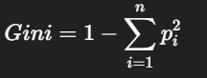​
Fig 2.1.2: Gini impurity
- Information Gain (based on Entropy): Measures the reduction in entropy achieved after the dataset is split on an attribute.
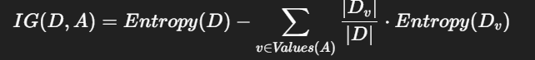
Fig 2.1.2: Gain
2. Random Forest Classifier
Random Forest is an ensemble learning method that combines multiple Decision Trees to create a more accurate and stable model. It is one of the most widely used classifiers for fraud detection due to its robustness and high accuracy.
Working Mechanism:
- Random Forest builds a 'forest' of decision trees by training each tree on a bootstrapped subset (random sample with replacement) of the training data.
- At each node split, it considers a random subset of features instead of all features (unlike a normal decision tree), which reduces correlation between trees.
- Final prediction is made using majority voting for classification or averaging for regression.
Mathematical Concepts:
- Bootstrap Aggregation (Bagging): Randomly samples subsets of the training data and trains a model on each

2.2. Data Preparation
2.2.1 Data Description
The dataset used in this project contains information about UPI transactions. Each row shows details of one transaction, such as the time it happened (step), the type of transaction (like TRANSFER or CASH_OUT), and the amount of money sent. It also includes the sender’s and receiver’s account balances before and after the transaction. The main goal is to find out whether a transaction is fraud or not. This is shown by the is Fraud column, where 1 means it is a fraud and 0 means it is a normal transaction. Most of the transactions in the data are not fraud, so it’s important to build a model that can detect the few fraud cases correctly.
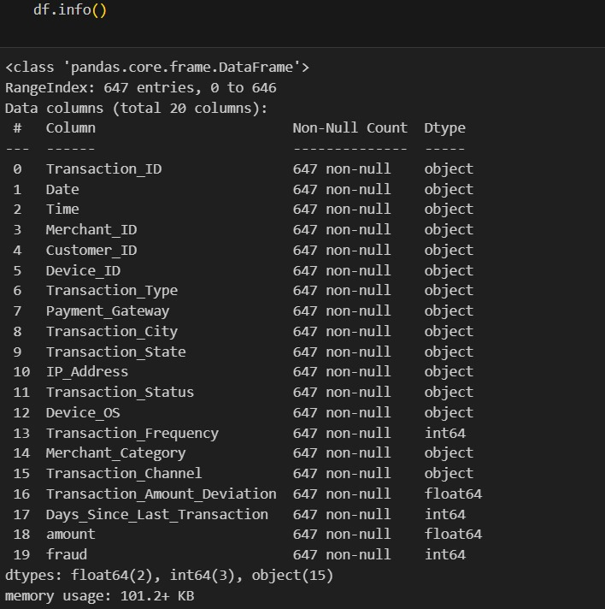
Fig 2.1.1: Information of the data set
- The info() method displays all the columns with data type and null count.

Fig 2.1.1: shape method
- This shape displays the count of rows and columns.

2.2.2 Data Preprocessing
1. Importing Libraries
Essential libraries used:
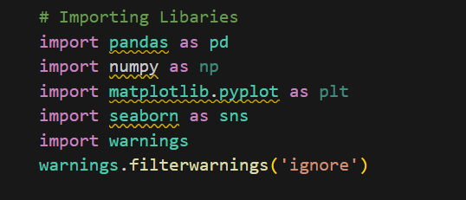
Fig 2.2.2.1: libraries
2. Loading Dataset
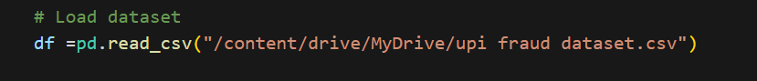
Fig 2.2.2.2: load dataset
3. Basic Data Cleaning
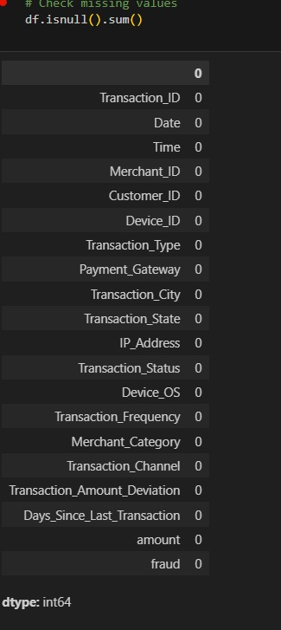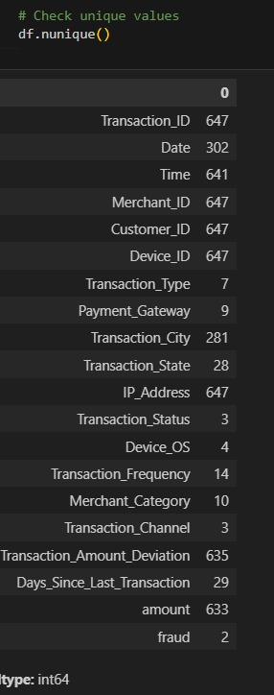
Fig 2.2.2.3:isnull() Fig 2.2.2.4:unique values

- Feature Selection

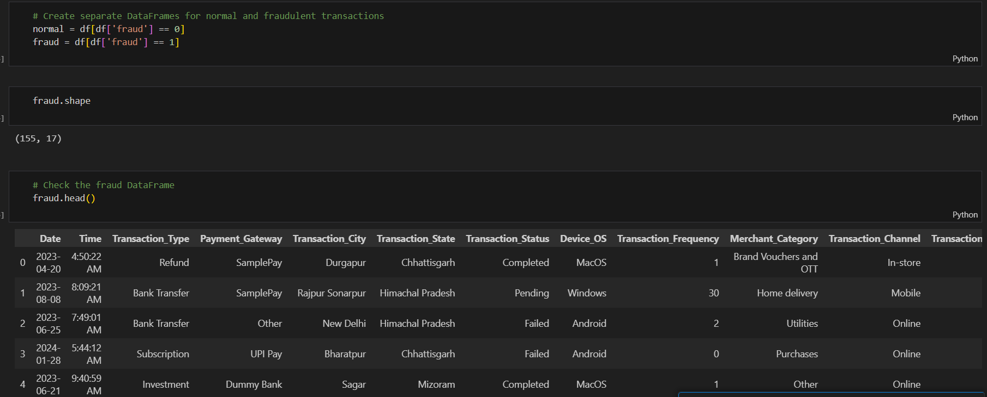
Fig 2.2.2.5: feature selection

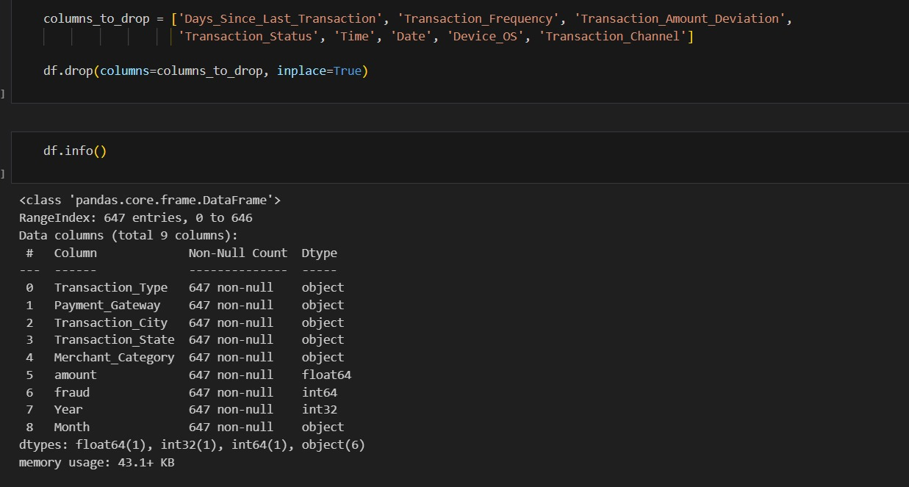
Fig 2.2.2.6: After feature selection

CHAPTER 3
RESULTS

This chapter discusses the results obtained from the application of machine learning models for detecting fraudulent UPI transactions. The objective was to compare and evaluate the performance of two models—Decision Tree Classifier and Random Forest Classifier—in identifying fraudulent behavior from transaction data.
The models were evaluated on the basis of accuracy, confusion matrix, classification report, and learning efficiency.

3.1 Model Implementation and Training

After preprocessing the data, two machine learning models were trained using the scikit-learn library:
3.1.1 Decision Tree Classifier
A simple, interpretation model that forms the baseline for comparison.
An ensemble learning model that combines multiple decision trees for improved accuracy and reduced over-fitting.
3.1.2 Random Forest
Random Forest is an ensemble learning method that combines multiple Decision Trees to create a more accurate and stable model. It is one of the most widely used classifiers for fraud detection due to its robustness and high accuracy.

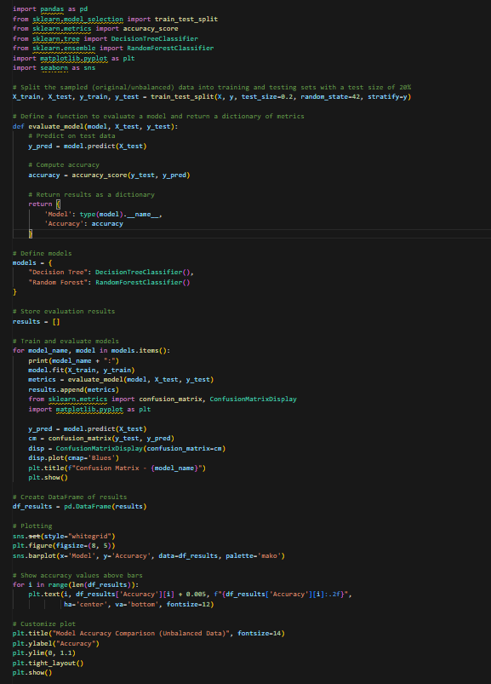
Fig 3.1.1:training model code

3.2 Accuracy Score
Accuracy is a basic metric that measures how often the model correctly classifies transactions.
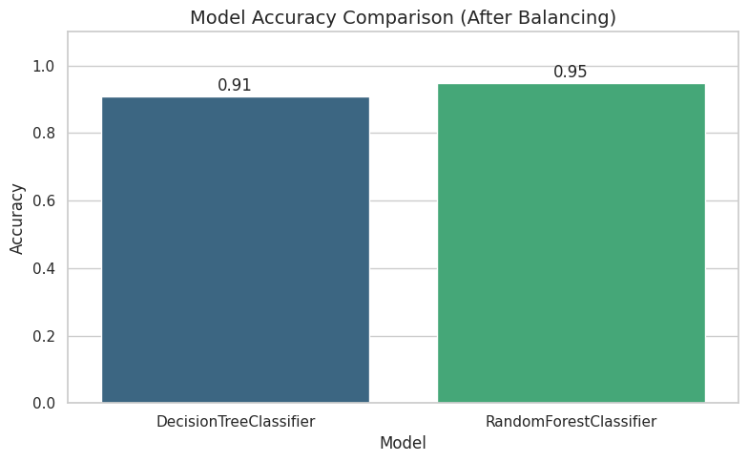
Fig3.2.1: Accuracy
3.3 Confusion Matrix
The confusion matrix shows the number of correct and incorrect predictions broken down by class. This is crucial in imbalanced datasets like fraud detection, where one class (fraud) is much less frequent.
cm = confusion_matrix(y_test, y_pred)
disp = ConfusionMatrixDisplay(confusion_matrix=cm)
disp.plot(cmap='Blues')
plt.title(f"Confusion Matrix - {model_name}")
plt.show()
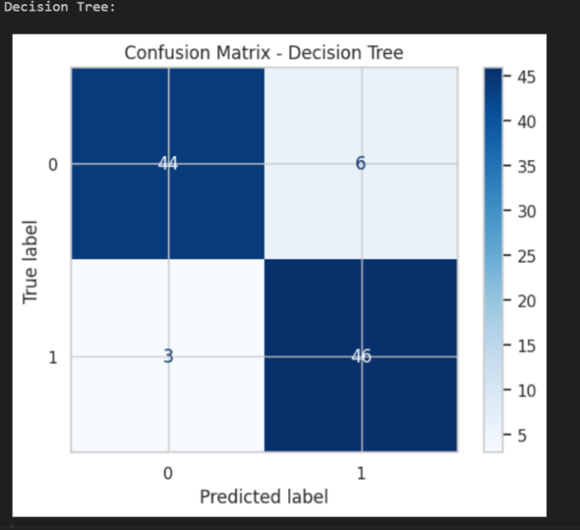
Fig 3.3.1: Decision tree
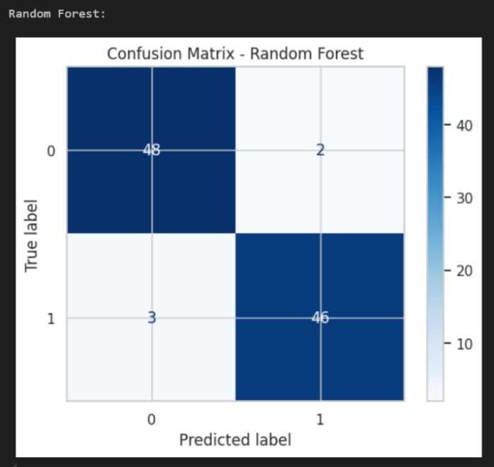
Fig 3.3.2:Random Forest
3.4 Classification Report
This includes precision, recall, and F1-score, which are more reliable for imbalanced classification problems.
from sklearn.metrics import classification_report
print(classification_report(y_test, y_pred))
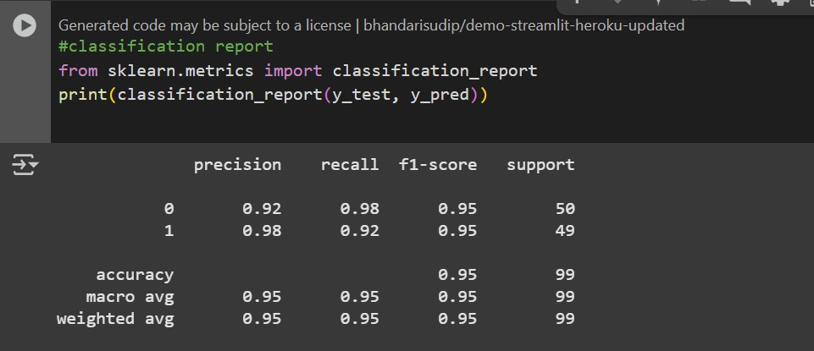
Fig 3.4.1 Classification report
Metric Definitions:
- Precision: Proportion of predicted frauds that were correct.
- Recall: Proportion of actual frauds that were detected.
- F1-Score: Harmonic mean of precision and recall, especially important in imbalanced datasets.
CHAPTER 4
CONCLUSION AND FUTURE SCOPE

4.1 Conclusion
- The Random Forest algorithm proved to be a highly effective model for classification tasks.
- By using an ensemble of decision trees and introducing randomness, it achieved high accuracy and robust performance, especially after data balancing.
- Compared to single models like Decision Trees, Random Forests significantly reduce over-fitting and provide better generalization on unseen data.
- Its ability to handle large datasets with higher dimensions makes it a reliable and scalable choice for real-world applications.

4.2 Future Scope
Hyperparameter Tuning:
- Use techniques like Grid Search or Random Search to fine-tune parameters such as n_estimators, max_depth, and max_features for optimal performance.
Feature Importance Analysis:
- Leverage Random Forest’s ability to rank feature importance to understand which variables influence predictions the most.
Integration with Other Models:
- Combine Random Forest with boosting techniques (like XGBoost or LightGBM) for even better accuracy and speed.
Model Optimization:
- Implement parallel processing to reduce training time for large datasets.

REFERENCES

1. National Payments Corporation of India (NPCI). Available at: https://www.npci.org.in/

2. Kaggle – UPI Transactions Dataset (Used for Fraud Detection). Available at: https://www.kaggle.com/

3. Brownlee, J. (2020). Imbalanced Classification with Python: Better Machine Learning on Imbalanced Datasets. Machine Learning Mastery.

4. Pedregosa, F., Varoquaux, G., Gramfort, A., Michel, V., Thirion, B., Grisel, O., ... & Duchesnay, E. (2011). Scikit-learn: Machine Learning in Python. Journal of Machine Learning Research, 12, 2825–2830.

5. Breiman, L. (2001). Random Forests. Machine Learning, 45(1), 5–32.

6. Quinlan, J. R. (1986). Induction of Decision Trees. Machine Learning, 1(1), 81–106.

7. Chawla, N. V., Bowyer, K. W., Hall, L. O., & Kegelmeyer, W. P. (2002). SMOTE: Synthetic Minority Over-sampling Technique. Journal of Artificial Intelligence Research, 16, 321–357.

8. Ribeiro, M. T., Singh, S., & Guestrin, C. (2016). “Why Should I Trust You?”: Explaining the Predictions of Any Classifier. Proceedings of the 22nd ACM SIGKDD International Conference on Knowledge Discovery and Data Mining.

9. Lundberg, S. M., & Lee, S.-I. (2017). A Unified Approach to Interpreting Model Predictions. Advances in Neural Information Processing Systems (NeurIPS).

10. Python Software Foundation. Python Language Reference, version 3.x. Available at: https://www.python.org/

SESHADRI RAO GUDLAVALLERU ENGINEERING COLLEGE
(An Autonomous Institute with Permanent Affiliation to JNTUK, Kakinada)
Seshadri Rao Knowledge Village, Gudlavalleru
Department of CSE (Artificial Intelligence & Machine Learning)

Program Outcomes (POs)

Engineering Graduates will be able to:
- Engineering knowledge: Apply the knowledge of mathematics, science, engineering fundamentals, and an engineering specialization to the solution of complex engineering problems.
- Problem analysis: Identify, formulate, review research literature, and analyze complex engineering problems reaching substantiated conclusions using first principles of mathematics, natural sciences, and engineering sciences.
- Design/development of solutions: Design solutions for complex engineering problems anddesign system components or processes that meet the specified needs with appropriate consideration for the public health and safety, and the cultural, societal, and environmental considerations.
- Conduct investigations of complex problems: Use research-based knowledge and research methods including design of experiments, analysis and interpretation of data, and synthesis of the information to provide valid conclusions., component, or software to meet the desired needs.
- Modern tool usage: Create, select, and apply appropriate techniques, resources, and modern engineering and IT tools including prediction and modeling to complex engineering activities with an understanding of the limitations.
- The engineer and society: Apply reasoning informed by the contextual knowledge to assess societal, health, safety, legal and cultural issues and the consequent responsibilities relevant tothe professional engineering practice.
- Environment and sustainability: Understand the impact of the professional engineering solutions in societal and environmental contexts, and demonstrate the knowledge of, and need forsustainable development.
- Ethics: Apply ethical principles and commit to professional ethics and responsibilities and norms of the engineering practice.
- Individual and team work: Function effectively as an individual, and as a member or leader in diverse teams, and in multidisciplinary settings.

- Communication: Communicate effectively on complex engineering activities with the engineering community and with society at large, such as, being able to comprehend and write effective reports and design documentation, make effective presentations, and give and receive clear instructions.
- Project management and finance: Demonstrate knowledge and understanding of the engineering and management principles and apply these to one’s own work, as a member and leader in a team, to manage projects and in multidisciplinary environments.
- Life-long learning: Recognize the need for, and have the preparation and ability to engage in independent and life-long learning in the broadest context of technological change.

Program Specific Outcomes (PSOs)
PSO1 : Design, develop, test and maintain reliable software systems and intelligent systems.
PSO2 : Design and develop web sites, web apps and mobile apps.

PROJECT PROFORMA

Classification of  Project | Application | Product | Research | Review
 | √
Note: Tick Appropriate category

Machine Learning Outcomes
Course Outcome (CO1) | Describe machine learning and different forms of learning.
Course Outcome (CO2) | Use statistical learning techniques to solve a class of problems.
Course Outcome (CO3) | Build support vector machine for the given data to create optimal boundary  that best classifies the data.
Course Outcome (CO4) | Design neural networks to simulate the way human brain analyzes and processes information.
Course Outcome (CO5) | Solve classification problems using a decision tree.

Mapping Table
CS3509 : MACHINE LEARNING
Course Outcomes | Program Outcomes and Program Specific Outcome
 | PO 1 | PO 2 | PO 3 | PO 4 | PO 5 | PO 6 | PO 7 | PO 8 | PO 9 | PO 10 | PO 11 | PO 12 |  | PSO 1 | PSO 2
CO1 | 1 | 1 |  |  |  |  |  |  |  |  |  | 1
CO2 | 1 |  |  |  |  |  |  |  |  |  |  | 1
CO3 | 2 | 3 | 2 |  |  |  |  |  |  |  |  | 2 |  | 1
CO4 | 2 | 2 | 3 | 2 |  |  |  |  |  |  |  | 2 |  | 2
CO5 | 1 | 2 | 3 | 1 |  |  |  |  |  |  |  | 2 |  | 1

Note: Map each Data Mining outcomes with POs and PSOs with either 1 or 2 or 3 based on level of mapping as follows:

1-Slightly (Low) mapped 2-Moderately (Medium) mapped 3-Substantially (High) mapped

